Passport and Visa Regime Requirements
Introduction
The administrative and legal regime of foreigners’ and stateless persons’ stay in Ukraine is determined by a set of international and national legal acts defining the foreign citizens’ rights and obligations. They are, in particular, Universal Declaration of Human Rights (1948), International Covenant on Human Rights (1966), UN General Assembly Resolution 40/411 "Declaration on the Human Rights of Individuals Who are not Nationals of the Country in which They Live" (1985), Constitution of Ukraine (1996), Law of Ukraine "On the Legal Status of Foreigners and Stateless Persons" (2012).
Certain foreign students’ rights and responsibilities to study and stay in Ukraine for study purposes, as well as the peculiarities of their implementation are established, in particular, by Resolution of the Cabinet of Ministers of Ukraine № 150 "On approval of the Procedure for extension of stay and extension or reduction of foreigners’ and stateless’ persons temporary stay in Ukraine" (2012), Resolution of the Cabinet of Ministers of Ukraine of April 25, 2018 No 322 “On approval of sample and technical description of the form for the temporary residence permits and the procedures for processing, issuing, exchanging, withdrawing, invalidating, and its annulling” (2018), Order of the Ministry of Education and Science of Ukraine № 1541 “Some issues of organization of recruitment and training (internship) of foreigners and stateless persons”(2013). Knowledge of these legal requirements will allow foreign students to feel more confident both in relations with government agencies of Ukraine and with the administration of higher education institutions.
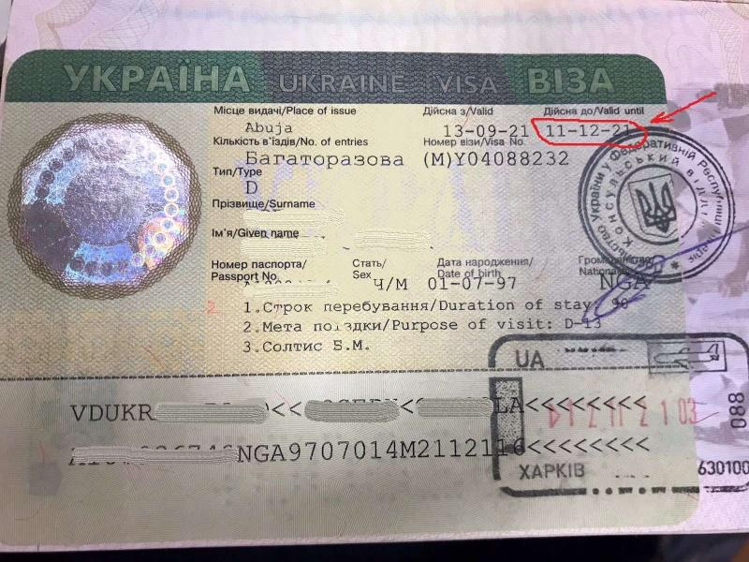
Welcome to Ukraine! We wish you interesting and unforgettable student years!
Foreign students enter Ukraine through checkpoints at the state border with a national passport and a visa type D-13 (Fig. 1), except for citizens of countries with which Ukraine's international agreements establish visa-free entry. While entering Ukraine, officers of the State Border Guard Service mark the crossing of the state border of Ukraine. The visa gives the right to stay on the territory of Ukraine during its validity period, but to obtain Temporary Residence Permit in Ukraine (TRP) a foreign student must apply to the State Migration Service (SMS) of Ukraine not later than 15 WORKING days before the visa expiry.
Citizens of countries with which Ukraine has a visa-free regime may stay in Ukraine legally for more than 90 days for 180 days. The application for Temporary Residence Permit must be made not later than 15 WORKING days before the end of the established period of stay.
Please note that before submitting documents for processing of Temporary Residence Permit, the educational institution must enroll you, prepare the relevant applications, so we advise you to start the preparation procedure immediately after entering Ukraine, but not less than 1 month before expiry date of the established period of stay.
Issuance of Temporary Residence Permit in Ukraine
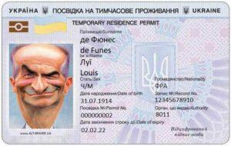
Temporary Residence Permit in Ukraine is issued to foreign students (students of Preparatory Course) for the entire period of study. Temporary Residence Permit allows the student to stay on the territory of Ukraine for the purpose of study during the period of study, to enter and leave Ukraine, to travel through its territory on weekends, holidays and vacations, but does not entitle to employment. International students are not allowed to work or engage in entrepreneurial activities, even in their free time. Violation of this prohibition may result in the State deciding to cancel Temporary Residence Permit, which will also lead to expulsion from the university.
In order to apply for Temporary Residence Permit, a foreign student personally submits the following documents to the territorial department of SMS or an authorized state enterprise:
1) passport with a visa type D-13 and a mark of crossing the state border of Ukraine;
2) a notarized passport translation into Ukrainian;
3) valid medical insurance policy for the entire term of Temporary Residence Permit;
4) a document confirming the fact of study in Ukraine (certified in the prescribed manner copies of the enrollment order and the establishment of periods of study);
5) certificate of a foreign student’s study generated in USED;
6) a letter from an educational institution containing an obligation to inform SMS about a foreigner’s expulsion from the institution;
7) payment slip confirming payment for the administrative fee for the service.
Temporary Residence Permit is issued by the body to which the documents were submitted, within 15 working days from the date of documents acceptance from a foreigner.
After obtaining Temporary Residence Permit, students are required to register their place of residence in Ukraine within 30 days.
Residence Registration
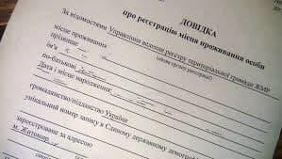
Issues of residence registration are regulated, in particular, by Resolution of the Cabinet of Ministers of Ukraine of March 02, 2016 № 207 "On approval of the Rules of residence registration and the Procedure for transfer of information to the Unified State Demographic Registry". International students studying in Ukraine on a full-time basis and those who received Temporary Residence Permit are obliged to register their place of residence in Ukraine within 30 calendar days after obtaining Temporary Residence Permit, as evidenced by a Certificate of residence registration. Residence Registration is carried out by the Executive Body of the City Council. Documents for registration / deregistration of residence / stay of a person are submitted to the registration authority, including the administrative services center.
In case of change of residence, foreigners must apply to the registration authority for a new address registration. The place of a new address residence registration takes place simultaneously with the deregistration from the previous foreigner’s place of residence. Registration of a foreigner's place of residence takes place only at one address, but the legislation does not set restrictions on the registration of a place of residence for several persons at the same address.
The necessary documents are as follows:
1) application;
2) Temporary Residence Permit in Ukraine;
3) payment slip confirming payment for administrative fee;
4) document confirming the right of housing ownership located at the address of a foreigner's future residence; lease / rental agreement for residence registration.
Non-compliance with the established procedure for movement and change of residence in Ukraine entails a fine from 1,700 UAH to 3,400 UAH.
Extension of Stay in Ukraine
In exceptional cases, when for an important reason a foreign student did not have time to apply to the territorial division of SMS or an authorized state enterprise within the statutory period for registration of Temporary Residence Permit, the law gives the opportunity to extend their stay in Ukraine for up to one month.
Applications for extension of stay in Ukraine are submitted by foreigners and stateless persons and the host party not earlier than ten and not later than three working days before the expiration of such period to the territorial bodies or departments of SMS at the place of residence. To extend the period of stay on the territory of Ukraine, a foreigner and a stateless person and the host party shall submit the following documents together with the application:
1) passport document with a visa type D-13 and a mark of crossing the state border of Ukraine;
2) a notarized translation of a page of a foreigner’s passport document with personal data into Ukrainian;
3) passport document of the head of the legal entity that is the host party and / or the person authorized by him;
4) a copy of the extract from the Unified State Registry of Legal Entities and Individuals - Entrepreneurs;
5) a copy of the administrative document (order, extract from the protocol, power of attorney, etc.) on the appointment of employees responsible for processing documents to foreigners and stateless persons, certified in the manner prescribed by law;
6) a document confirming the availability of financial security to cover the costs associated with the stay of a foreigner and a stateless person in Ukraine, or a letter of guarantee from the host party to undertake to pay all costs associated with the stay of a foreigner and stateless persons on the territory of Ukraine and their departure from Ukraine;
7) a document on the right of ownership or a certificate of state registration of ownership of a legal entity for housing provided to a foreigner and a stateless person for residence and a copy thereof, and in case the housing does not belong to the host party - written consent of the owner (co-owner) or a person authorized by him;
8) payment slip confirming the payment of state duty for extension of stay.
Expulsion from Higher Educational Institution
In case of expulsion from the university due to graduation or other reasons, including violation of the contract or violation of terms of agreement, or non-fulfilment of the curriculum, higher educational institution must inform the territorial body of SMS within 10 days about a foreign student’s expulsion.
If a foreigner intends to continue their studies in Ukraine at another university, they apply to a new institution during the specified period, submits the necessary documents, fulfills the admission requirements for the purpose of enrollment. The issue of foreign students’ transfer from one educational institution to another is resolved by agreement between educational institutions according to the following procedure:
1) agree on the transfer to another educational institution in International Office of your university, get copies of the documents required for admission (transfer);
2) find out the admission requirements to the new university, get from it a letter of consent for admission;
3) submit a letter of consent to your university, receive the original documents and a letter of consent for the transfer to a new university;
4) make sure that within 10 days from the moment of expulsion you have fully fulfilled the admission requirements and have been enrolled to continue your studies in a new educational institution.
In other cases, the foreign student must submit Temporary Residence Permit to International Office and leave the territory of Ukraine within 10 days after expulsion. The university must give a letter confirming the return of the Temporary Residence Permit, to which a copy of a Temporary Residence Permit is attached.
Responsibility for Violation of Passport and Visa Regime Requirements
In case of violation of the passport and visa regime requirements and the regime of stay in Ukraine by a foreign citizen, the law of Ukraine presupposes the measures of administrative influence.
Below there are extracts from Code of Ukraine on Administrative Offenses.
Article 203. Violation by foreigners and stateless persons of the rules of stay in Ukraine and transit through the territory of Ukraine
Violation by a foreigner or a stateless person of the rules of stay in Ukraine, i.e. living without documents for the right to live in Ukraine, invalid documents or documents which validity has expired, or employment without a permit, if such permission is required by Ukrainian law, or non-compliance with established procedure for moving and changing the place of residence, or evading departure from Ukraine after the expiration of the relevant period of stay, non-arrival to a certain place of study without important reason or employment after entering Ukraine within a specified period, as well as violation of transit rules through Ukraine , in addition to the violations provided for in part two of this Article, -
entail the imposition of a fine from one hundred to three hundred non-taxable minimum incomes.
Non-compliance with the established procedure for registration or residence in Ukraine on invalid documents or expired documents, or violation of the established period of stay in Ukraine, found at checkpoints across the state border of Ukraine or in 'entry and exit checkpoints', -
entail a warning or a fine from one hundred to three hundred non-taxable minimum incomes.
Article 203-1. Non-compliance with the decision to ban entry into Ukraine
Intentional non-fulfillment by a foreigner or a stateless person of a decision of an authorized state body prohibiting entry into Ukraine -
entails the imposition of a fine from one hundred to three hundred non-taxable minimum incomes.
Article 204. Violation of the order of employment, admission to study, provision of housing, registration of foreigners and stateless persons and registration of documents for them
Violation by officials of enterprises, institutions and organizations, regardless of ownership, including foreign economic entities operating in Ukraine, individuals - entrepreneurs who use hired labor of established procedure for employment, admission of foreigners and persons statelessness, providing them with housing, as well as other violations, if they in any way assist foreigners and stateless persons to evade leaving Ukraine after the expiration of their stay or are aimed at their illegal registration, registration of residence documents, -
entail the imposition of a fine from one hundred to two hundred non-taxable minimum incomes.
Article 204-1. Illegal crossing or attempt to illegally cross the state border of Ukraine
Crossing or attempting to cross the state border of Ukraine in any way outside the checkpoints across the state border of Ukraine or at checkpoints across the state border of Ukraine without relevant documents or using forged documents or those containing inaccurate identity or without the permission of relevant authorities -
entail the imposition of a fine from two hundred to five hundred non-taxable minimum incomes or administrative arrest for up to fifteen days, with confiscation of weapons and means of committing the offense.
The same actions committed by a group of persons or a person who during the year was subjected to administrative penalties for one of the violations provided for in part one of this Article -
entail the imposition of a fine from five hundred to eight hundred non-taxable minimum incomes or administrative arrest for a term of ten to fifteen days, with confiscation of weapons and means of committing the offense.

Article 205. Non-act to take measures to ensure timely registration of foreigners and stateless persons
Non-act to take measures to ensure timely registration of foreigners and stateless persons by citizens who invited them -
entails a warning or imposition of a fine from twenty to forty non-taxable minimum incomes.
Article 206. Violation of the procedure for providing housing, vehicles and assistance in providing other services to foreigners and stateless persons
Provision of housing and vehicles to foreigners and stateless persons, assistance in their illegal registration, registration of residence or study documents, employment, as well as other services in violation of the established rules of stay of foreigners and stateless persons in Ukraine and their transit rules through the territory of Ukraine, if these actions are not directly related to the illegal crossing of persons the state border of Ukraine, -
entail the imposition of a fine from three hundred to five hundred non-taxable minimum incomes.
Article 206-1. Illegal transportation of foreigners and stateless persons through the territory of Ukraine
Transportation by drivers of foreigners and stateless persons in violation of the established rules of stay of foreigners and stateless persons in Ukraine and their transit through the territory of Ukraine, if these actions are not directly related to illegal crossing of persons across the state border of Ukraine -
entails the imposition of a fine from one hundred to two hundred non-taxable minimum incomes.
Actions provided for in part one or two of this Article, if committed repeatedly or by a group of persons, or in respect of several foreigners and stateless persons, as well as transportation of foreigners and stateless persons in vehicles or special shelters for transportation of people -
entail the imposition of a fine from one hundred and seventy to five hundred non-taxable minimum incomes of citizens with or without confiscation of vehicles.
Administrative penalties can be applied not only to foreigners who have violated the relevant requirements, but also to staff of educational institutions, homeowners, and others who have tried to help you stay safe and comfortable in Ukraine. Therefore, we ask you to faithfully follow the above rules to prevent negative consequences.

List of Regulations:

- Code of Ukraine on Administrative Offenses of 07.12.1984 № 8073-X, https://zakon.rada.gov.ua/laws/show/80731-10#Text
- Law of Ukraine "On the legal status of foreigners and stateless persons" of September 22, 2011. № 3773-VI, https://zakon.rada.gov.ua/laws/show/3773-17#Text
- Resolution of the Cabinet of Ministers of Ukraine of April 25, 2018 No 322 “On approval of sample and technical description of the form for the temporary residence permits and the procedures for processing, issuing, exchanging, withdrawing, invalidating, and its annulling", https://zakon.rada.gov.ua/laws/show/322-2018-%D0%BF#Text
- Resolution of the Cabinet of Ministers of Ukraine of February 15, 2012 № 150 "On approval of the Procedure for extension of stay and extension or reduction of temporary stay of foreigners and stateless persons on the territory of Ukraine", https://zakon.rada.gov.ua/laws/show/150-2012-%D0%BF#Text
- Resolution of the Cabinet of Ministers of Ukraine of March 2, 2016 № 207 "On approval of the Rules of residence registration and the Procedure for transfer of information by registration authorities to the Unified State Demographic Registry ", https://zakon.rada.gov.ua/laws/show/207-2016-%D0%BF#Text
- Order of the Ministry of Education and Science of Ukraine of November 01, 2013. № 1541 "“Some issues of organization of recruitment and training (internship) of foreigners and stateless persons", https://zakon.rada.gov.ua/laws/show/z2004-13#Text

 | English
1 | To enter Ukraine for study purposes, you must obtain:  - long-term visa;  - visa type D-13;  - visa type D-12;  - any Visa.
2 | To enter Ukraine for study purposes is allowed:  - during the period of the visa validity;  - not later than 15 days before the end of the visa;  - not earlier than 15 days before the start of training;  - all variants.
3 | To obtain/extend Temporary Residence Permit in Ukraine the documents must be applied to:  - Admission Committee of the University;  - International office of the University;  - State Migration Service;  - Registration authority.
4 | To obtain Temporary Residence Permit in Ukraine the documents must be applied:  - not later than the visa expiry date;  - 15 days before the visa expiry date;  - 15 working days before the visa expiry date;  - all variants.
5 | To extend Temporary Residence Permit in Ukraine the documents must be applied:  - 15 days before the Temporary Residence Permit expiry date;  - 15 working days the Temporary Residence Permit expiry date;  - 15 days before graduation;  - not defined by law.
6 | To obtain Temporary Residence Permit in Ukraine the following needs to be submitted:  - the original and a copy of a passport;  - the original and a passport translation;  - the original and a notarized translation of the passport;  - a copy and a notarized translation of the passport.
7 | A foreigner is obliged to register the place of residence (two answers):  - during the visa validity;  - within 30 days from entering Ukraine;  - within 30 days from the date of receipt of the Temporary Residence Permit;  - within 30 days from the moment of change of residence.
8 | To register the place of residence, documents can be submitted to (two answers):  - Registration authority;  - State Migration Service of Ukraine;  - Administrative Services Centre;  - University Passport Service.
9 | After graduation and expulsion from the university a foreigner:  - can be enrolled in another university within 10 days;  - or can be enrolled on another program within 10 days;  - or must leave the territory of Ukraine;  - everything is correct.
10 | International students have the right to work in Ukraine:  - during the holidays;  - in free time from studying;  - all of the above is true;  - do not have the right to work.

